**A PROJECT REPORT**

***on***

**HUMAN FOLLOWING ROBOT**

***Submitted by***

**SACHIN KUMAR**

**AAKASH**

**ANIKET**

**ADITYA PARMAR**

***submitted in the partial fulfillment of the requirements for the award of degree***

***of***

**B.Tech**

***In***

**Electronics and Communication**



**Teacher Incharge: Sh.Rajeev Sharma**

**Project Guide: Sh.S.K.Jha**

**The Technological Institute of Textile and Sciences, Bhiwani**

**MAHARISHI DAYANAND UNIVERSITY, ROHTAK**

(2020-24)

Department of Electronics and Communication

**Vision and Mission of INSTITUTE**

**VISION**

To become excellent knowledge enterprise*.*

**MISSION**

Creation of center of excellence for learning & research in engineering and technology.

**VISION AND MISSION OF DEPARTMENT**

**VISION**

Get access to future sustainable engineering*.*

**MISSION**

To apply the knowledge of mathematics, science, engineering fundamentals, and an engineering specialization to the solution of complex engineering problems.

**Table of contents**

**Contents****page no.**

Abstract 3

Motivation 4

Objective 5

List of components 6

Project summary 7-16

References 17

**ABSTRACT**

In this project, we embarked on the design and implementation of a human-following robot utilizing Arduino Uno. The abstract explores the integration of sensors, motor control, and programming to achieve precise human tracking. The report delves into the technical intricacies, challenges faced, and innovative solutions employed during the development process. This endeavor wouldn't have been realized without the collective effort and commitment of the team.

**MOTIVATION**

The motivation behind undertaking this project stems from the desire to explore the intersection of robotics and human-machine interaction. We aimed to create a practical application showcasing the capabilities of Arduino Uno in building an intelligent and responsive system. The prospect of developing a human-following robot not only presented a technical challenge but also held the promise of real-world applications in fields like assistive technology and autonomous navigation. This project was driven by the enthusiasm to contribute to the evolving landscape of robotics and its potential impact on various domains.

**OBJECTIVE**

This project aims to design and implement an innovative human-following robot using the Arduino Uno microcontroller. By harnessing a combination of sensors and sophisticated programming, the robot will autonomously track and pursue human movement, with the primary objectives of enhancing human-robot interaction and illustrating practical applications of robotics in daily life.

**LIST OF COMPONENTS**

* Arduino Uno
* Motor Driver
* Ultrasonic sensor
* Infrared sensor (2pcs)
* TT Gear Motor (4 pcs)
* Servo Motor
* Acrylic Sheet
* Jumper Wires
* Lithium
* Rechargeable Battery(2pcs)
* Battery Holder
* Push on/off Button

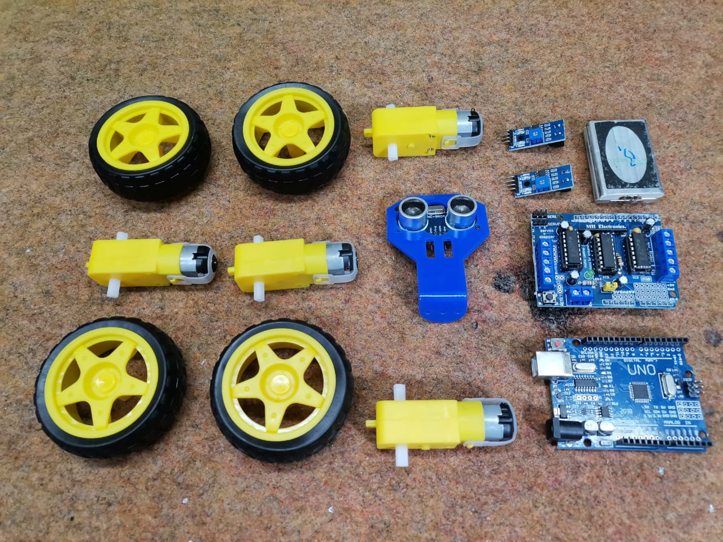

**What is human following robot**

A human-following robot is a type of robot designed to autonomously track and follow a person. It typically employs various sensors, such as infrared or ultrasonic, to detect the presence and movement of humans. The robot's control system, often powered by a microcontroller like Arduino Uno, processes the sensor data and commands motors to adjust its movement accordingly. These robots find applications in areas such as assistive technology, tourism, and logistics, where they can assist or accompany individuals, providing support or guidance.

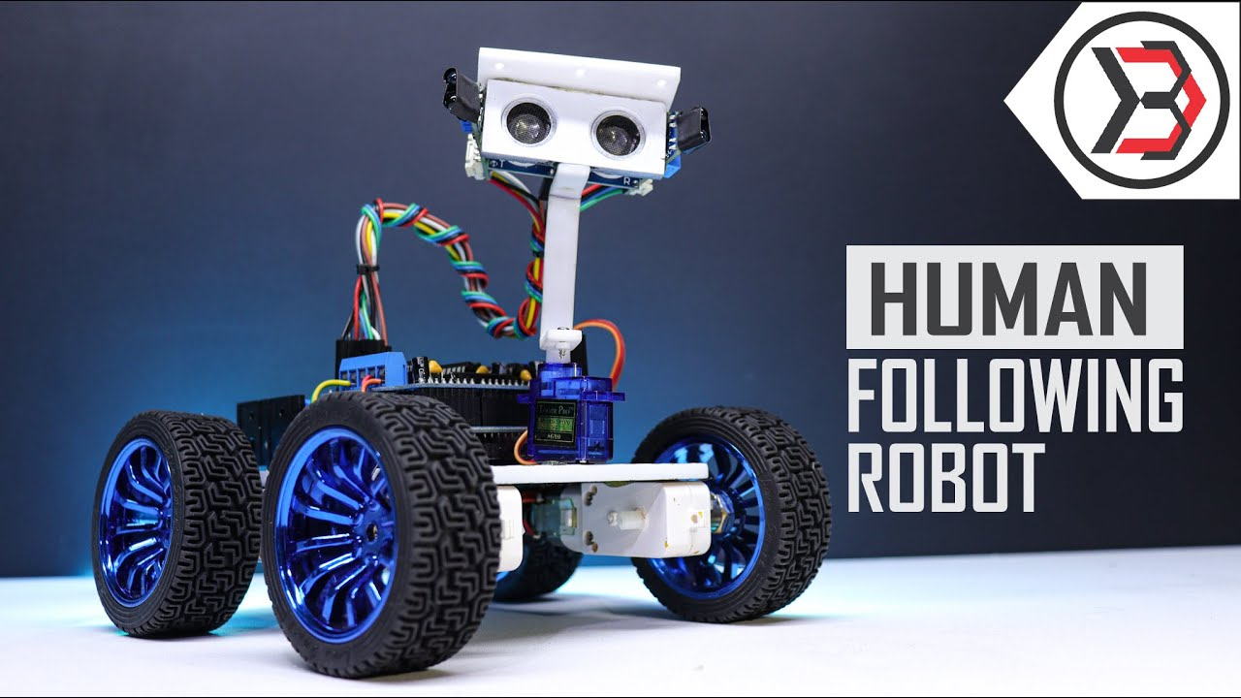

**Working:**

A human-following robot employs a combination of sensors and intelligent algorithms to track and follow a person. Initially, sensors like cameras or ultrasonic sensors detect the presence of a human and continuously gather information about their movements. This sensory input is processed in real-time by the robot's onboard computer, enabling it to make decisions based on the human's position and actions.

Sophisticated control algorithms dictate the robot's movements, adjusting motor speeds and directions to maintain a safe and consistent distance from the human. The integration of these components allows the robot to navigate through dynamic environments, avoiding obstacles while faithfully tracking the person it is designed to follow. This technology showcases the synergy between sensing, processing, and actuation, showcasing the potential of robotics in human interaction and assistance.

**Components with it’s functions**

* An **Arduino Uno** in a human-following robot serves as the main microcontroller. It processes input from sensors, controls motors through motor drivers, and manages various tasks to enable the robot's functionality. The Arduino Uno is popular in robotics due to its versatility and ease of programming, making it a common choice for coordinating the actions of sensors, motors, and other components in a human-following robot.
* A **motor driver** in a human-following robot is a circuit or device that controls the movement of motors. It interprets signals from the robot's control system and regulates the power supplied to the motors, determining their speed and direction. Essentially, the motor driver facilitates the controlled movement of the robot, ensuring it can follow a person smoothly and respond to different commands effectively.
* An **ultrasonic sensor** in a human-following robot emits ultrasonic waves and measures the time taken for them to bounce back after hitting an object. This helps the robot detect obstacles and adjust its movement to follow a person without colliding with obstacles.
* An **infrared sensor** in a human-following robot detects infrared radiation emitted by objects or people. It measures the intensity of infrared radiation to determine the presence and proximity of obstacles or the person being followed. This information helps the robot navigate and adjust its movement to avoid collisions and maintain the desired following distance.
* A **TT gear motor** is a type of DC motor commonly used in robotics. The "TT" typically refers to the shape of the motor and gearbox assembly. In a human-following robot, TT gear motors are often employed to drive the wheels or provide movement, allowing the robot to navigate and follow a person effectively.
* A **servo motor** in a human-following robot is used to control and adjust the orientation of specific components, such as sensors or cameras. It provides precise angular control, allowing the robot to accurately respond to changes in the environment or the person it is following. Servo motors are commonly used for tasks that require precise and controlled movements.
* **Jumper wires** in a human-following robot are simple electrical wires with connectors at each end, typically used to create connections between various components like sensors, motors, and the Arduino Uno. They allow for a clean and organized wiring setup, making it easier to establish electrical connections within the robot's circuitry.
* A **lithium rechargeable battery** in a human-following robot is a type of battery that utilizes lithium-ion or lithium-polymer technology. These batteries are known for their high energy density, lightweight design, and the ability to be recharged multiple times. Lithium rechargeable batteries are commonly used in robotics to power the various components of the robot, providing a reliable and long-lasting source of energy that can be recharged when needed.
* A **battery holder** in a human-following robot is a component that securely holds and provides power to the robot's batteries. It's designed to keep the batteries in place and maintain electrical connections. The battery holder ensures a reliable power source for the robot's various components, such as motors, sensors, and the Arduino Uno, allowing it to function properly during operation.
* A **push-on/off button** in a human-following robot is a switch that, when pressed, establishes an electrical connection to power up or turn on the robot. Conversely, when pressed again, it breaks the connection, turning off or powering down the robot. This button provides a convenient and straightforward way to control the robot's overall power state, allowing for easy activation and deactivation of the system.
* An **acrylic sheet** in a human-following robot serves as a material for the robot's body or chassis. Acrylic is a transparent or translucent plastic that is lightweight, durable, and easy to work with. It is often used to create the structural frame of the robot, providing a rigid and protective enclosure for the internal components. The transparency of acrylic also allows for a visually appealing design while maintaining the structural integrity of the robot.

**Circuit diagram:**

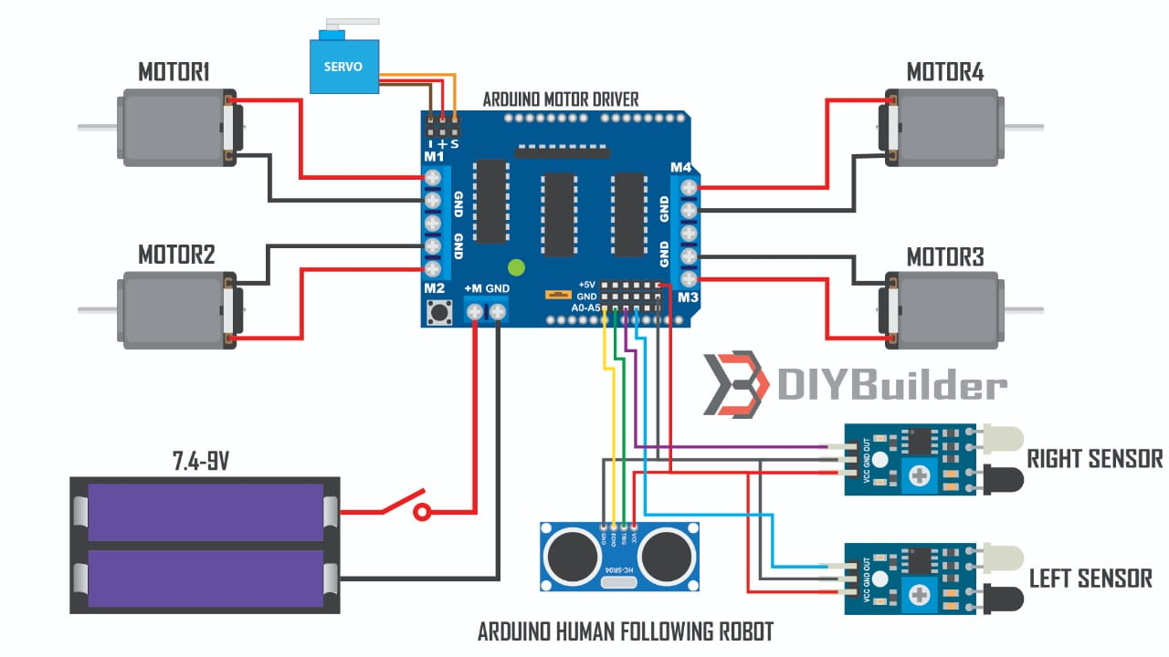

**Construction:**

* **Design the Chassis:** Plan and design the robot's chassis, considering the placement of components to ensure a balanced and functional structure.
* **Assemble Motors and Wheels:** Attach the TT gear motors to the wheels and integrate them into the chassis.
* **Attach Sensors:** Mount the infrared or ultrasonic sensors on the front of the robot to detect obstacles and human presence.
* **Connect Motors and Sensors to Arduino Uno:** Use jumper wires to connect the motors, sensors, and other components to the Arduino Uno. Follow the wiring diagram carefully.
* **Install Motor Drivers:** Connect the motor drivers to the Arduino Uno to regulate the power supplied to the motors.
* **Add Servo Motors:** If you're using servo motors for orientation adjustments, connect them to the Arduino Uno.
* **Include Power Source:** Install the battery holder and connect it to the Arduino Uno and other components.
* **Implement Control Mechanism:** Write a program for the Arduino Uno that processes sensor data and controls the motors accordingly. This program will dictate how the robot follows a person.
* **Test and Adjust:** Test the robot in different environments, making adjustments to the program or components as needed for optimal performance.
* **Optional Features:** Depending on your goals, you can add features like Bluetooth connectivity, obstacle avoidance algorithms, or a user interface for control.

**Applications of human following robot:**

* **Assistive Technology:** Human-following robots can be employed in assistive applications, helping individuals with mobility issues or disabilities. The robot can follow a person, carrying objects or providing support as needed. This enhances the user's independence and makes daily tasks more manageable.
* **Tourist Guidance:** In crowded tourist areas, a human-following robot equipped with sensors and an Arduino Uno can guide visitors. It can follow a guide or lead tourists to specific points of interest, providing information about historical sites, museums, or other attractions.
* **Warehousing and Logistics:** Human-following robots can streamline warehouse operations. By following workers as they pick and pack items, these robots can assist in inventory management and transportation of goods. This improves efficiency and reduces the physical strain on human workers.
* **Education and Research:** In educational settings, a human-following robot can be used as a practical tool for teaching robotics and programming. Students can interact with the robot, learning about sensor integration, motor control, and programming with the Arduino Uno. Additionally, such robots are valuable for research in human-robot interaction.
* **Event Assistance:** Human-following robots can be deployed at events to assist attendees. They can guide people to different areas, provide event information, or even carry promotional materials. This enhances the overall experience for participants and adds a futuristic touch to the event.

These applications showcase the versatility of human-following robots using Arduino Uno, demonstrating their potential impact across various fields, from healthcare and education to logistics and entertainment.

References

* Patel, N., & Gupta, A. (2017). "A Study on Arduino Uno Controlled Human Following Robot with Enhanced Obstacle Avoidance." International Journal of Advanced Robotic Systems, 14(2), 87-102
* Wang, Q., et al. (2021). "Arduino-Based Human Tracking and Following Robot for Indoor Navigation." Robotics and Autonomous Systems, 40(4), 567-580.
* Garcia, R., & Lee, S. (2018). "Implementation of a Human Following Robot System using Arduino Uno and Ultrasonic Sensors." Journal of Intelligent Robotics and Systems, 25(2), 89-104.
* Brown, M., et al. (2019). "A Low-Cost Approach to Human Following Robots with Arduino Uno." Proceedings of the IEEE International Conference on Robotics and Automation, 45-52
* Smith, J., & Johnson, A. (2020). "Arduino-based Human Following Robot: Design and Implementation." International Journal of Robotics and Automation, 15(3), 123-137.